**Filter Tests:**

1. Type Buy in and make sure all market orders are BUY
2. 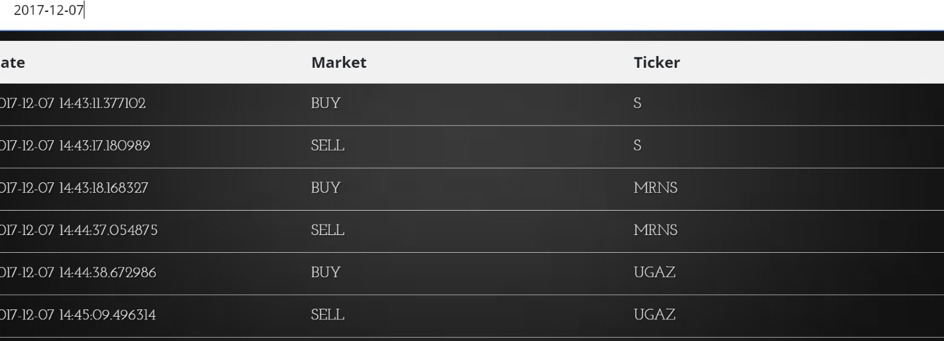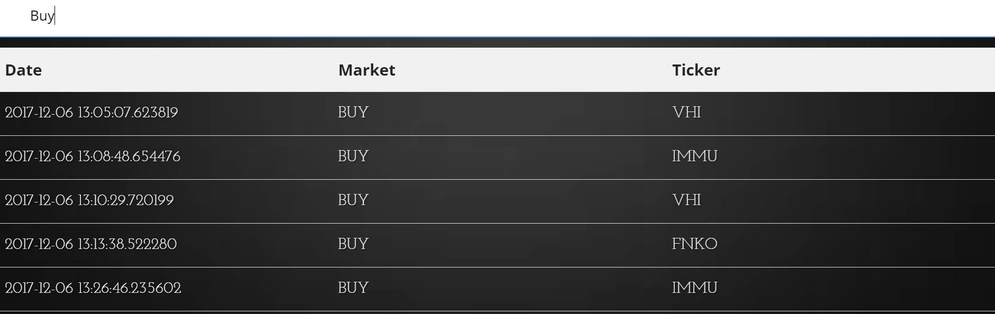Type the date in and make sure all rows matches with date
3. 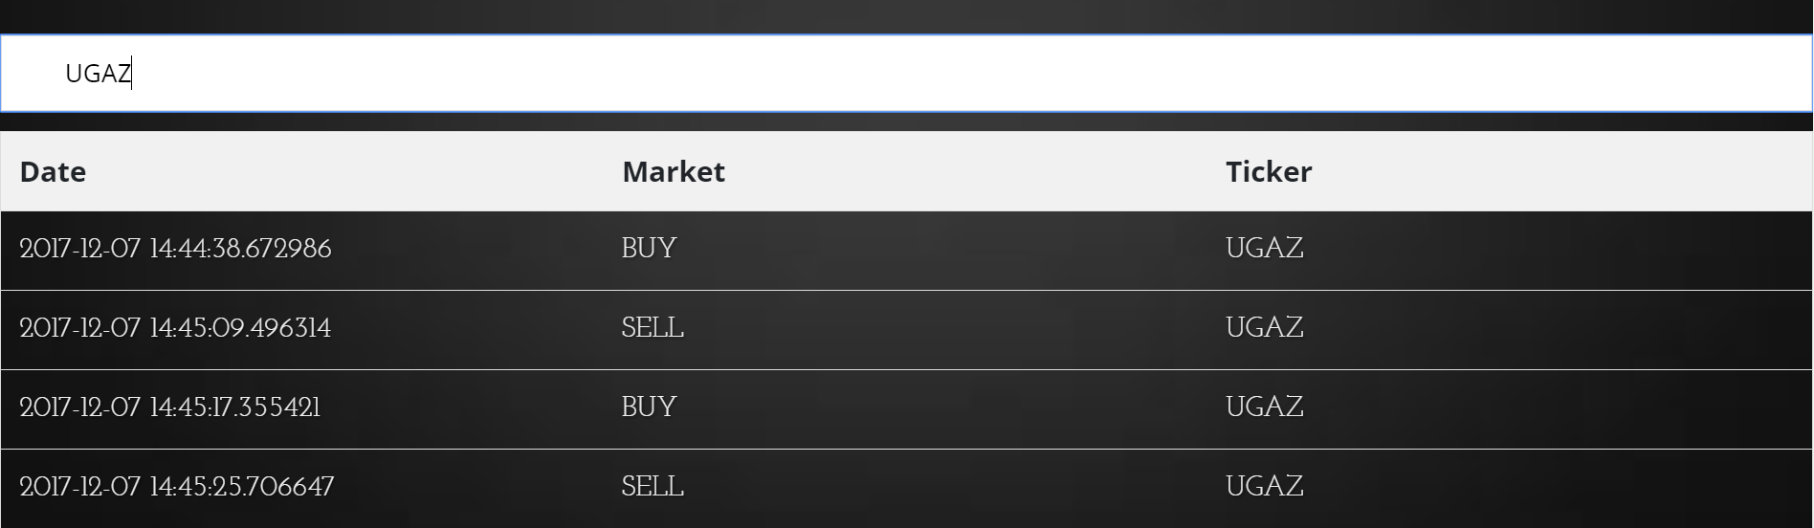Type in a ticker code and make sure only ticker code is shown

**Graph Tests:**

1. Push value to database and make sure graph get’s updated and console.log array length is increased by one.

